3.5 Chain Rule Worksheet

- Let

- By the Chain Rule, express and as functions of u and v.

We know that:

and

- Evaluate and at the point .

- Let and and . Calculate and and their values at the point .

We know that:

and

Therefore, at we have that and and thus

- Find where , and .

- Let . Let . What is ?

- If where and , find and .

- Suppose that . If is differentiable, show that satisfies the equation .

We let and . Then, , and by the chain rule:
So, we know that

- Suppose that a rectangle has two parallel sides which are growing at a rate of 2 m/s, while the other two sides are shrinking at a rate of 1m/s. Determine the rate at which the area of the rectangle is changing at the moment when sides which are increasing in size reach length 2m and the sides which are decreasing in size reach length 3m.

We can imagine of picture of a rectangle with changing side length as in the picture to the right.

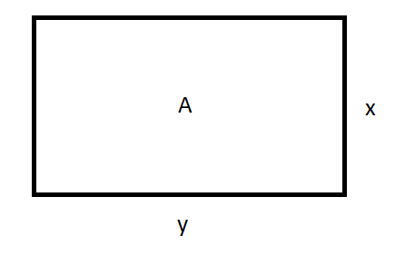
We know that and therefore

.

So, when we reach the lengths of 2m and 3m we see that:

- Suppose a cylinder’s volume is changing at a rate of 1cm³/sec as its height and radius grow. Determine the rate of change of the height of the cylinder at the moment when if it is known that the radius is growing twice as quickly as the height.

We know that the volume of the cylinder is given by .

Therefore, .

Since we know that the radius grows twice as quickly as the height, we know that and so we can rewrite of equation of related rates to say:

So, when we reach the moment when we have that:

- In physics we know that there is a relationship between how the velocity of an object changes when it is subjected to an external force. This is summarized with Newton’s second law of motion: (where m represents the mass of the object and a represents the acceleration of the object). Suppose that the mass of an object is decreasing at a rate of 2 kg/sec and its acceleration is increasing at a rate of 1(m/s²)/s. Determine the rate of change of the force acting on the object after 1 minute. Assume that the initial mass of the object is 500kg and the initial acceleration is 0 m/s². (Note that force here is measured in Newtons (N))

We know that .

Therefore, .

We know that and . We also know that after 1 minute the object will have lost of mass and will have increased its acceleration to . Therefore, we compute:

